**Week 3 Assignment – Landing, Login, and Enrollment Pages Development**

Vicki Kelm

The University of Arizona Global Campus

CST 499: Capstone for Computer Software Technology

Dr. Amjad Alkilani

January 14, 2024

**Week 3 Assignment – Landing, Login, and Enrollment Pages Development**

This paper will explain how to run a PHP file in XAMPP, discuss the MySQL database functions used and the steps taken to create the database connection custom class, explain the steps taken to create the registration page and to save the user information in the database, and provide screenshots of the landing, login, and registration pages, database, tables, layout, and source code.

**Explain how to run a PHP file in XAMPP**

The first step to run a PHP file is to download and install XAMPP on a computer. XAMPP is a web development tool that was created by Apache to easily run PHP scripts on a computer locally. Once XAMPP is installed, go to the start menu, search for XAMPP, then click on the XAMPP icon to launch and open the program. The program opens to the XAMPP Program Control Panel (Figure 1). Here the user will click on the “Start” button under the Actions column for both the “Apache” and “MySQL” modules to start the Apache Web Server and the MySQL application. Both modules will turn green when successfully powered on.

**Figure 1**

XAMPP Control Panel

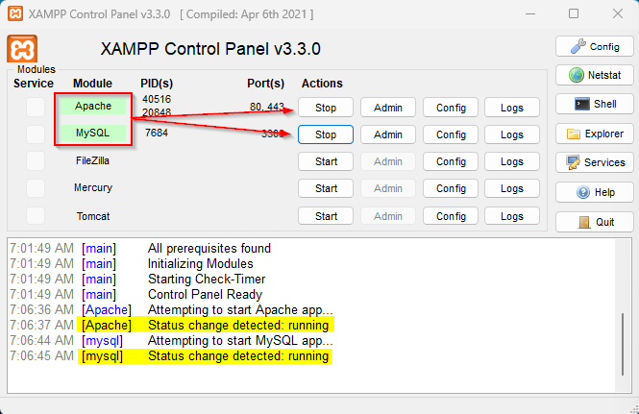

Once both services are running, next is to test to see if both are working. Start by opening a web browser (in my case, Edge). Type “localhost” in the navigation bar which produces the XAMPP Welcome Page (Figure 2), and then type “localhost/phpMyAdmin” to open the MySQL database application (Mikoluk, 2013) (Figure 3). The next step will be to create PHP files in the “htdocs” folder located under the “XAMPP” folder on the drive installed on. Most likely this will be the C: drive. The initial path will be made up of “your_drive_letter:/xampp/htdocs”. Here is where the shell files are created with each file being saved using the “.php” file extension.

**Figure 2**

XAMPP Welcome Page

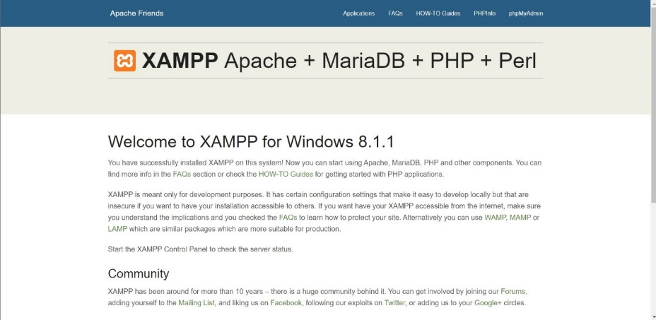

**Figure 3**

phpMyAdmin Screen

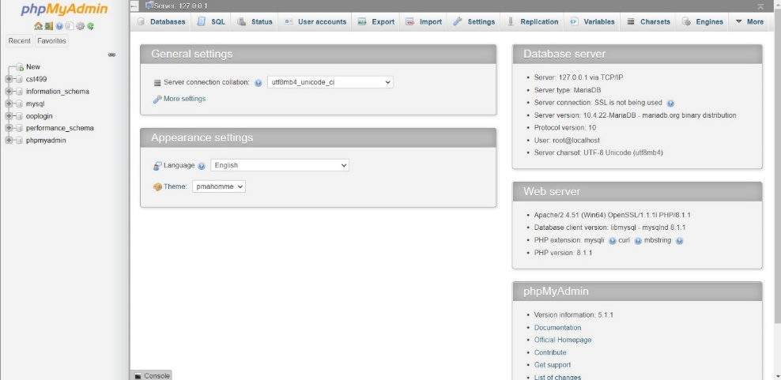

**Run file in XAMPP process:**

1. Create a sub-folder in the htdocs folder in the xampp directory
2. I created the sub-folder “test” in htdocs: Figure 4
3. Then I created a Text Document shell file with the file extension of .php: test.php
4. Then I added code to the test.php file: Figure 5
5. Then I opened a browser, and typed the file path in the navigation bar: localhost/test/test.php, then hit Enter
6. This produces the result of the code: Figure 6

**Figure 4**

htdocs directory

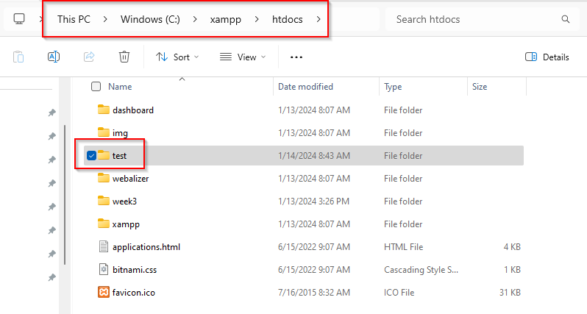

**Figure 5**

test.php code

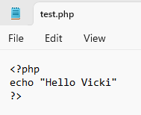

**Figure 6**

test.php result

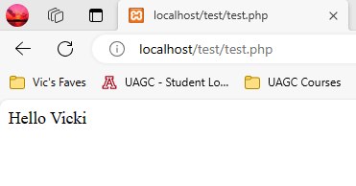

**Discuss the MySQL database functions used and the steps used to create the database connection custom class**

To create the database for the project, go to phpMyAdmin, then click on “New” in the left side panel. This opens up the Databases directory screen. Type the name of the new database in the “Database name” field box, then click the “Create” button. For this project, I chose to name my database “cst499” (Figure 7).

**Figure 7**

Database screenshot in phpMyAdmin

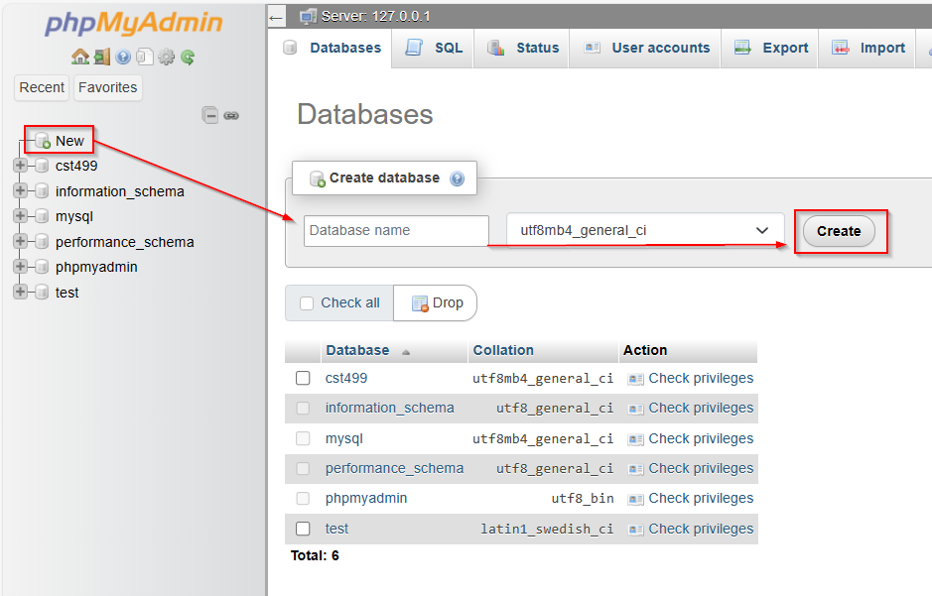

The next step will be to create a database table. I created a table labeled “users” in the “cst499” database for my project. The steps to create the table are below:

1. Click on the name of the database in the left side panel: cst499
2. Enter the name of the table in the “Table name” field box, select the number of columns needed, and the click the “Create” button or click on the “SQL” tab at the top of the page to enter code to create the table
3. I chose the SQL tab option, as this process is much easier – after entering the code in the SQL tab, click the “Go” button at the bottom of the page (Figure 8)
4. The result is a newly created table in the cst499 database

**Figure 8**

SQL code to create table “users” in the cst499 database

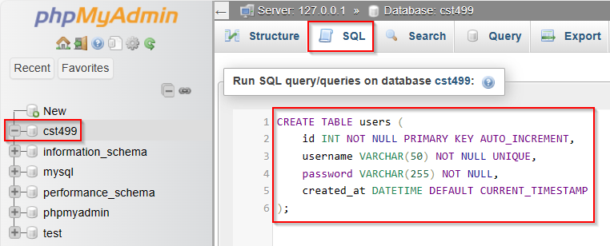

**Figure 9**

Created “users” table in the cst499 database

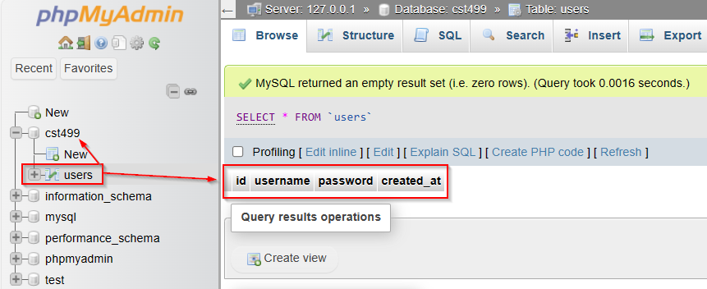

After creating the table, the next step is to create a PHP script to connect to the MySQL database server. I created a file named “config.php using the following code:

**Figure 10**

config.php

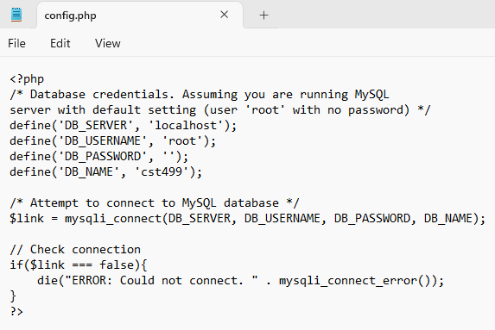

Note. I used TutorialRepublic for guidance on this step. I updated the DB_NAME to the name of my database, ‘cst499’.

**Explain the steps taken to create the registration page and to save user information in the database**

Steps to create the registration page and save user information in the database are as follows:

* Step 1: Open the XAMPP Control Panel: start the server
* Step 2: Create the PHP project directory: visit the xampp/htdocs directory and create the php project within the directory – I created the sub-folder “week3”
* Step 3: Create the database and table in phpMyAdmin: DB: cst499, Table: users
* Step 4: Create a database connection file: config.php
* Step 5: Create a registration form: register.php
* Step 6: Enter localhost/week3 into a web browser, click on the Registration button, then create an account to insert data into the cst499 database

**Provide screenshots of the landing, login, and registration pages, database, tables, layout, and source code**

**Landing Page:**



**Login Page:**

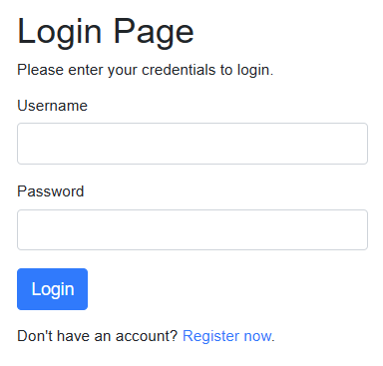

**Registration Page:**

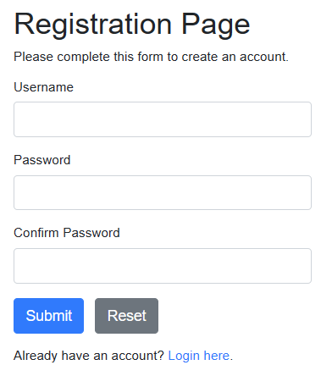

**Database and table: cst499 DB, users Table**

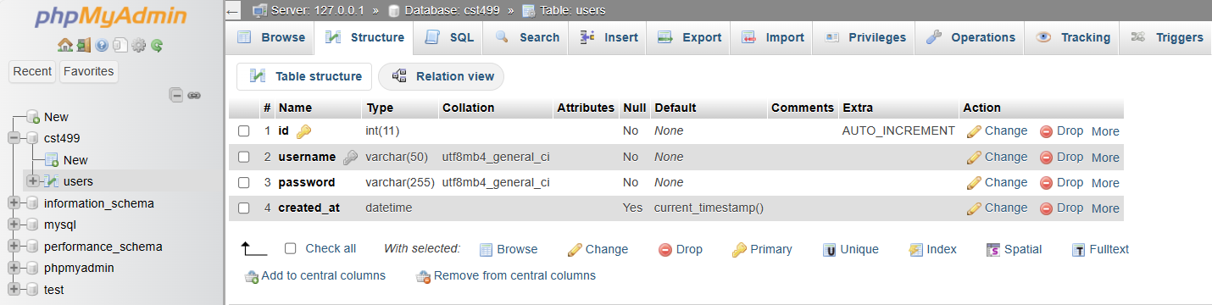

**PHP Files in xampp/htdocs directory:**

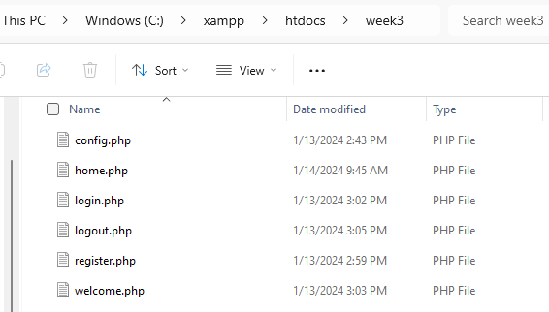

**Landing Page Source Code:**

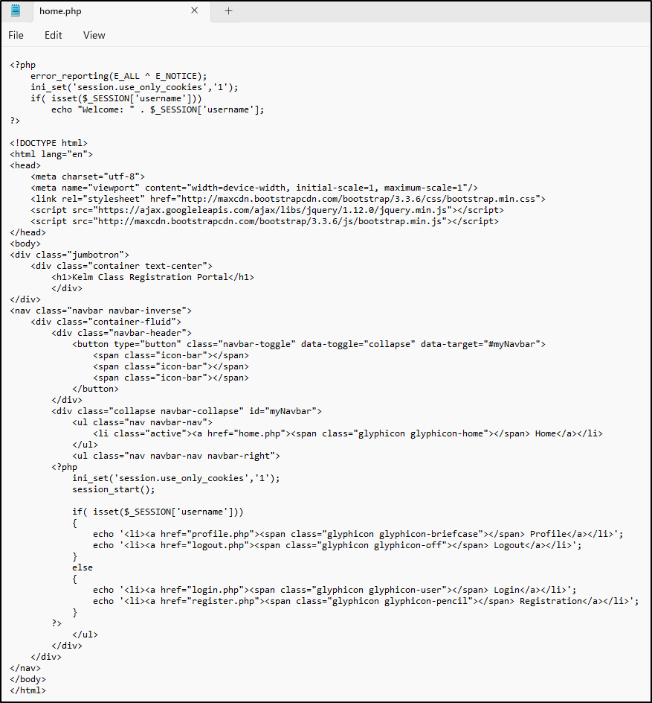

**Login Page Source Code: screenshot 1**

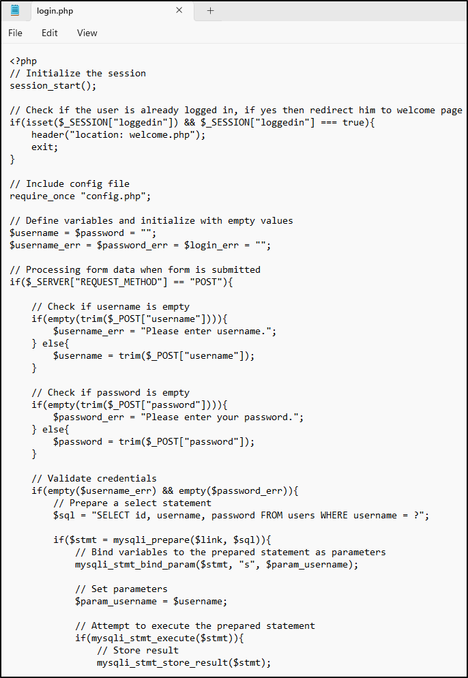

**Login Page Source Code: screenshot 2**

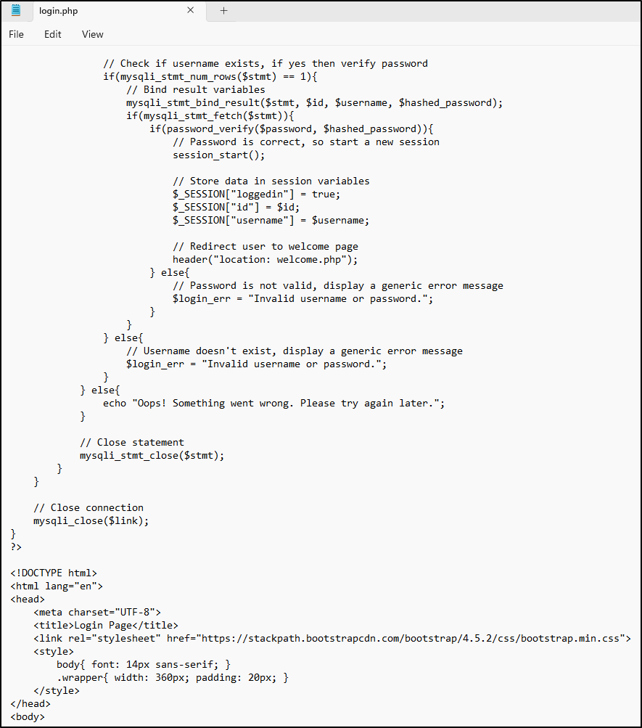

**Login Page Source Code: screenshot 3**

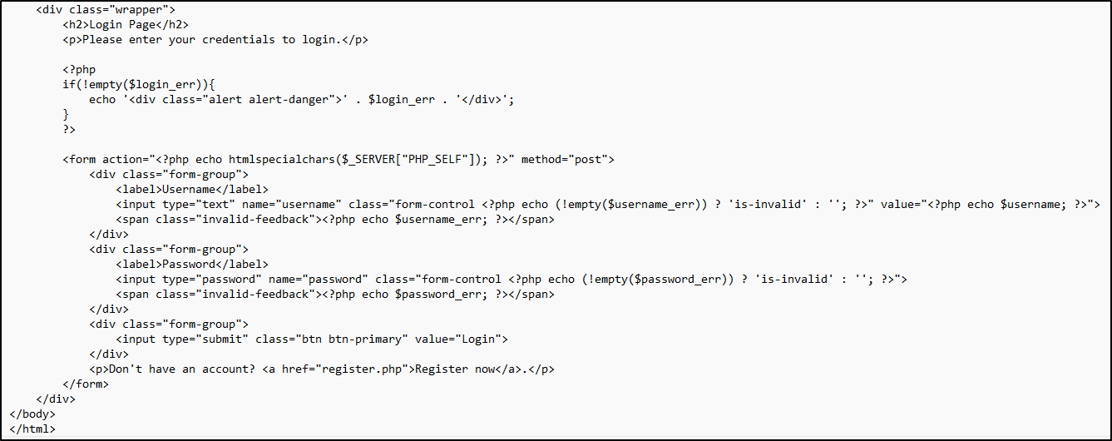

**Conclusion**

This paper explained how to run a PHP file in XAMPP, discussed the MySQL database functions used and the steps taken to create the database connection custom class, explained the steps taken to create the registration page and to save the user information in the database, and provided screenshots of the landing, login, and registration pages, database, tables, layout, and source code.

**References**

Mikoluk, K. (2013, September 18). [XAMPP tutorial: How to use XAMPP to run your own web serverLinks to an external site.](https://blog.udemy.com/xampp-tutorial). Udemy. https://blog.udemy.com/xampp-tutorial

Tsui, F., Karam, O., & Bernal, B. (2018). [Essentials of software engineering](https://uagc.instructure.com/courses/126521/modules/items/6439323)(4th ed.). Jones & Bartlett Learning.

TutorialRepublic. (n.d.). *PHP MySQL Login System*. <https://www.tutorialrepublic.com/php-tutorial/php-mysql-login-system.php>